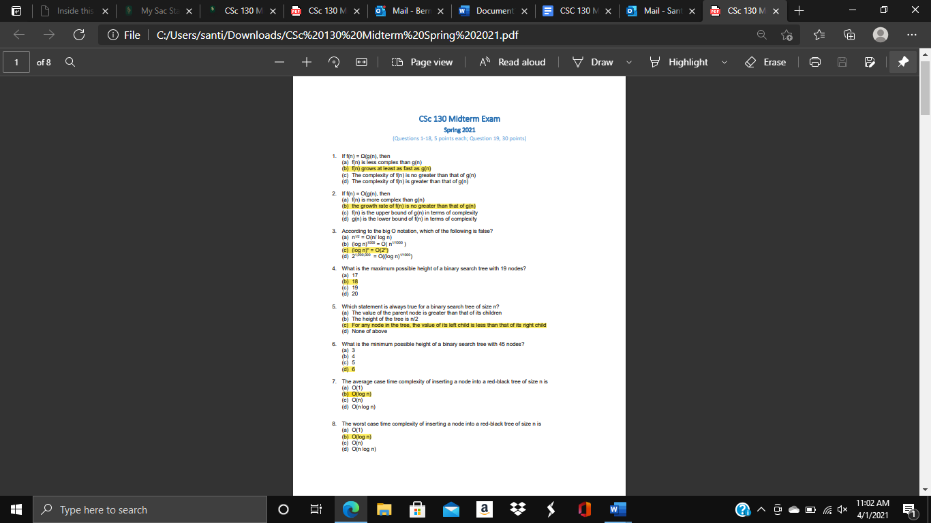

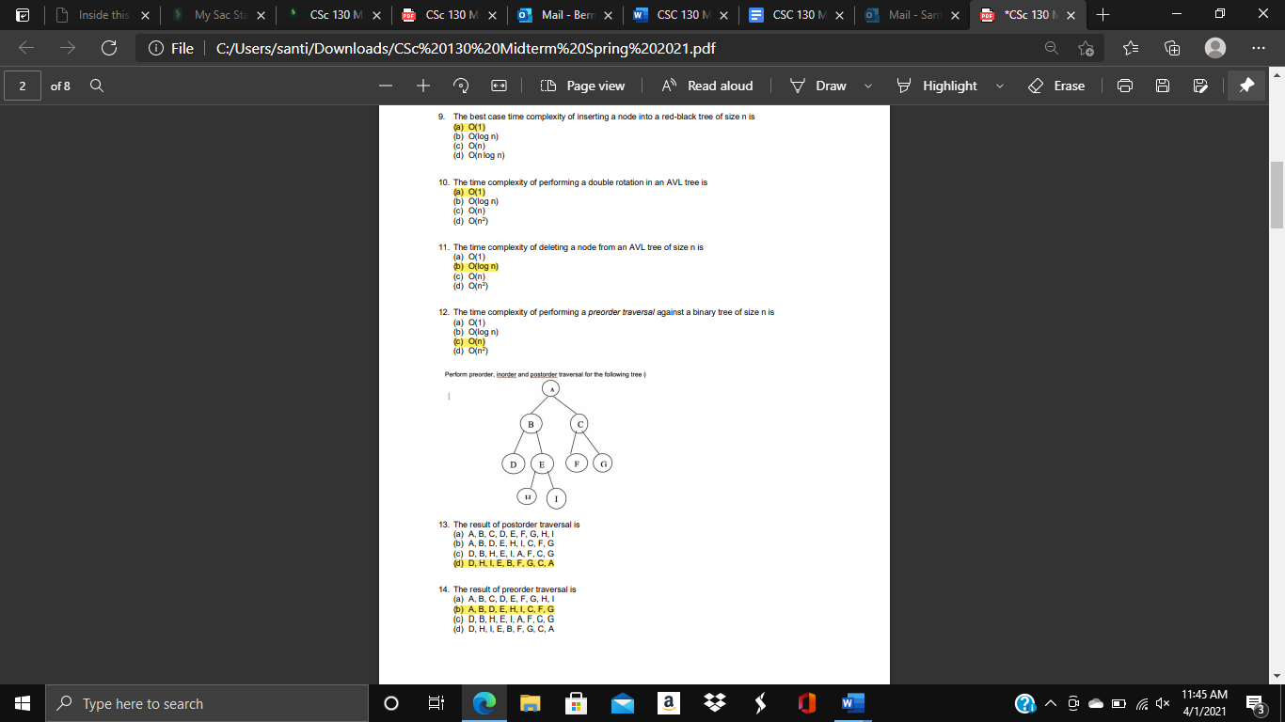

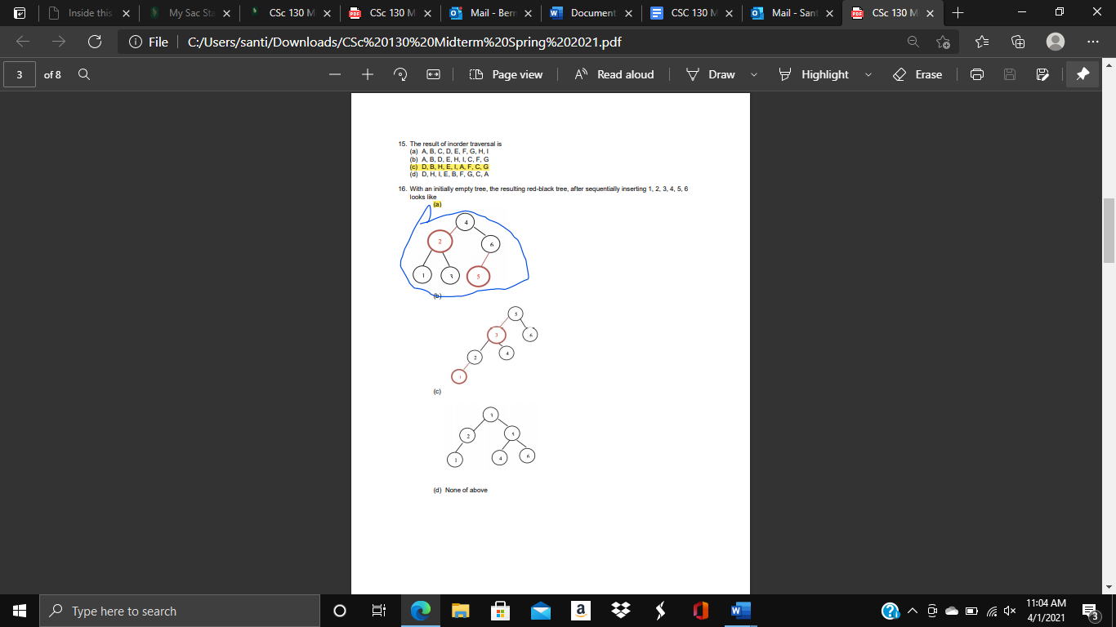

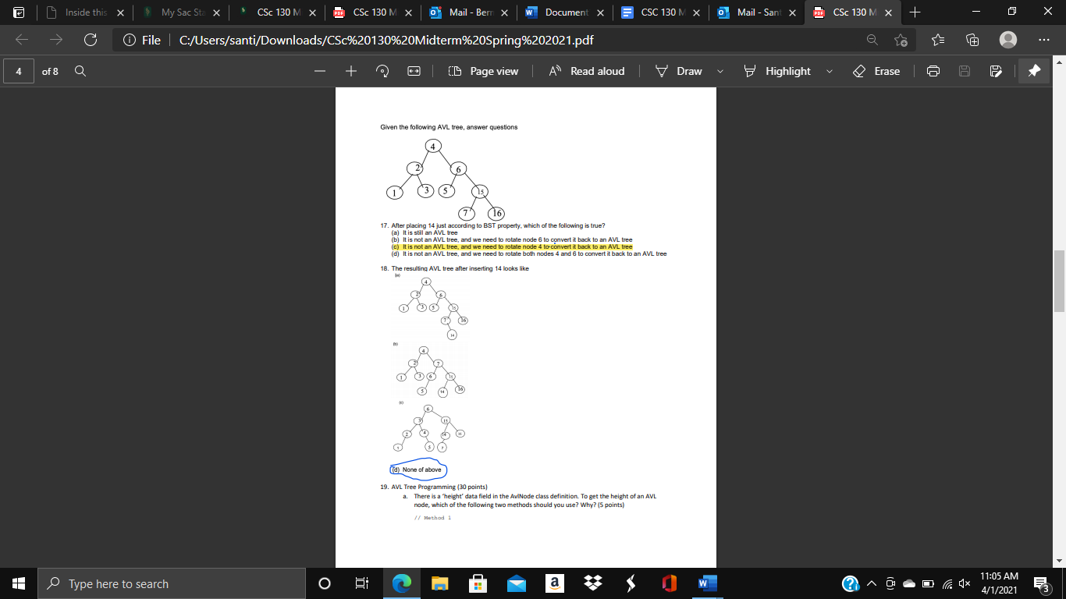

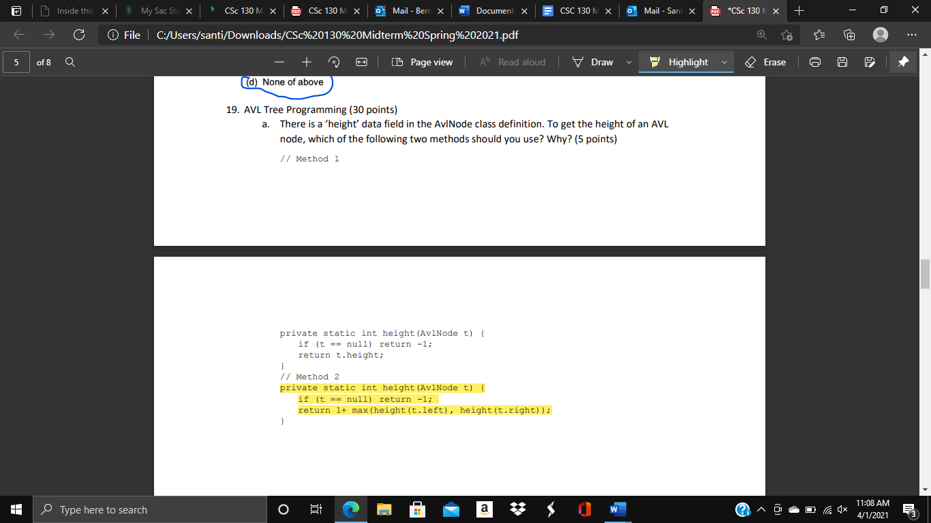

The reason why you would want to use method 2 is because it also takes into account the children that a node could have, which gives you the height accurately when compared to method 1, which only looks at the current node and nothing else.

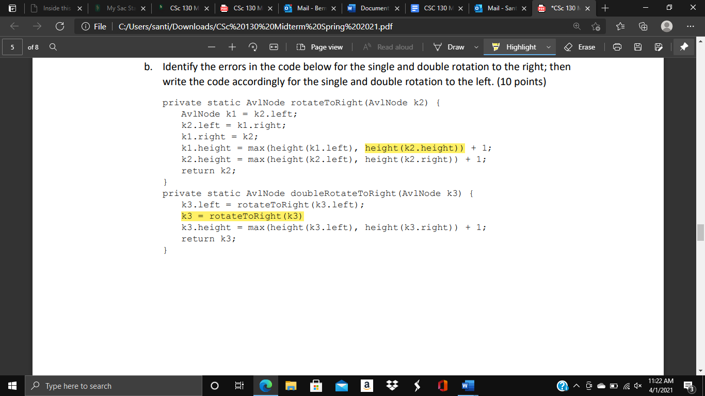

The first highlighted error should be “height(k1.right))” instead.

The second highlighted error should be “k3.left = k2.right” instead.

private static AvlNode rotateToLeft(AvlNode k2) {

AvlNode k1 = k2.right;

k2.right = k1.left;

k1.left = k2;

k1.height = max(height(k1.left), height(k1.right)) + 1;

k2.height = max(height(k2.left), height(k2.right)) + 1;

return k2

private static AvlNode doubleRotateToLeftAvlNode k3) {

k3.right = rotateToLeftt(k3.right);

K3.right = k2.left;

k3.height = max(height(k3.left), height(k3.right)) + 1;

return k3;

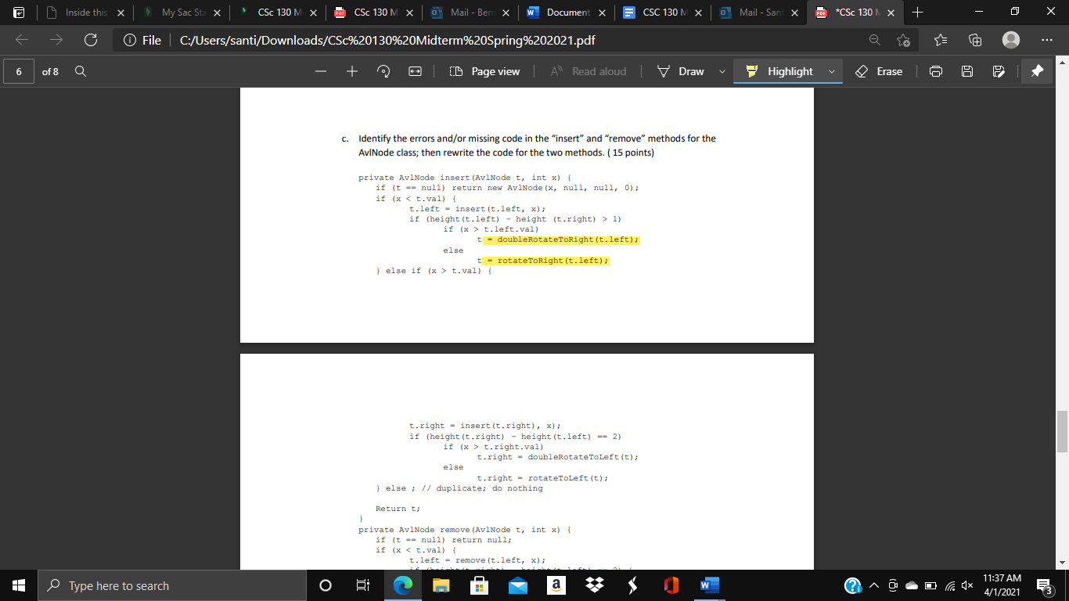

t = doubleRotateToRight(t.left); should be t.left = doubleRotateToRight(t);

t = rotateToRight(t.left); should be t.left = rotateToRight(t);

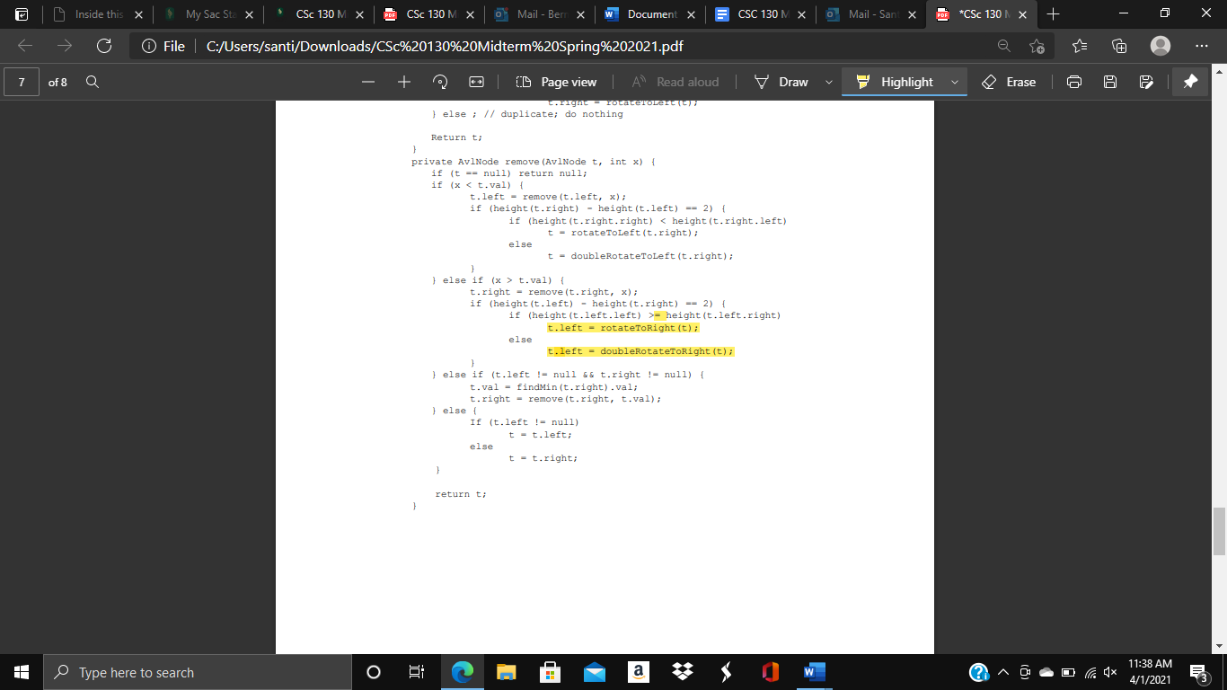

>= should just be >

t.left = rotateToRight(t); should be t= rotateToRight(t.left);

t.left = doubleRotateToRight(t); should be t= doubleRotateToRight(t.left);